Services
服务
The activities contained in the BPD describe the overall flow of the process and the diagram as a whole provides a readable description of the process. Although the BPD provides a great deal of information, it doesn't capture how the process is implemented. Consider the simple process of making a cup of tea in the morning. A simple process for this might look as follows:

包含在BPD里的活动描述了流程的整个大纲，同时，代表整个过程的图又给流程提供了一个通熟易懂的解释。尽管 BPD 提供了大量的信息，但是，还是没有准确的描述流程是怎么实现的。举个早上起来泡茶流程一个简单例子，这样一个流程可以做成下面的样子：

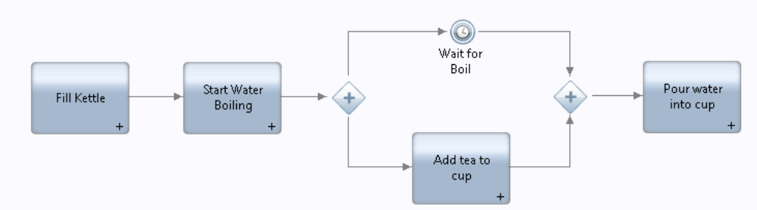

Reading this, we can quickly see the steps and their sequence. However, this diagram says nothing about how these steps are implemented. Since IBPM is not simply a diagramming tool but is also a powerful execution engine for running instances of such processes, we must also describe how each of the activities are implemented.

读到这，我们一眼就可以看出这些步骤和序列，但是，这个图表却不能说明这些步骤是怎么实现的。虽然IBPM 没有定义一个图表的工具，但是它有一个强大的运行工程，就是通过这些流程跑出一个实例。我们同时也必须描述每一个活动是怎么实现的。

IBPM utilizes the concept of a service to perform each step. A service provides a reusable implementation of a piece of function. How the server achieves its task is hidden from the caller. Mapping this idea to BPDs, each Activity in the BPD diagram will be mapped to a service and
when that step in the process is reached, the associated service will be invoked.

IBPM 用的是一个服务去执行每一个步骤的理念。一个服务提供的某一小块功能的实现，并且可以重复使用。从用户的角度看，是看不到一个server是怎么完成task 的。我们来把这种思想用到BPD 里面，在BPD 图表里面的每一个活动，都将会映射到相应的服务，并且，当流程的那一步骤访问的时候，相关联的服务将会被调用。

A service is a piece of implemented function of one of the following IBPM types:

实现某一块功能的服务有一下几种IBPM 类型
• Human Service
• Ajax Service (used only by Human Services)
• Integration Service
• General System Service
• Rules Service

- 人工服务
- Ajax 服务（被人工服务调用）
- 集成服务
- 基础系统服务
- 规则服务

The Service is usually called from the Activity step in a BPD. The identity of the Service to be
invoked is defined in the Implementation tab:

服务通常在一个BPD 里面被活动的步骤调用。被调用服务的属性定义在一个实现表里:

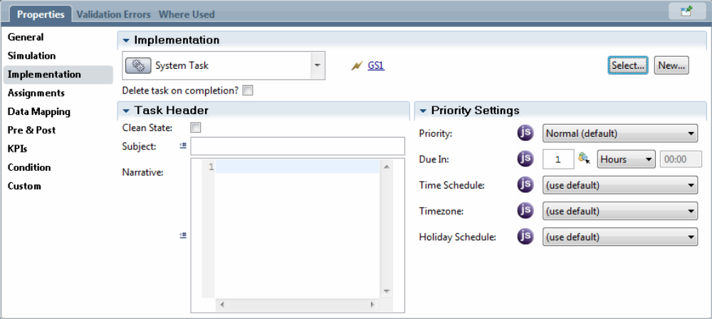

Note that the Implementation type is defined as a System Task. From there, the selection of the Service to be called can be selected.

注意：实现类型是被视为一种系统任务。被调用服务的选项是可以被选择的。

The Task Header area controls what is shown in the Process Portal for this step and what data is maintained after the activity completes.

任务的头部区域控制着这一步在Process Portal 平台的展示和后期活动完成数据的维护。

The Subject entry contains a textual description of this step in the process. This is shown in the Process Portal. It is used to provide the end user an indication or summary of what is expected. The Subject line can contain JavaScript and hence access the variables in the process to supply more details of what is needed.

标题实体包含一个在流程中对应步骤的一个文本描述。在Process Portal上会显示出来。它通常会被用在提供给终端用户的一个提示或者期望值总结。标题栏里还可以包含JavaScript ,这样做的目的是在访问变量的过程中，可以提供更多详细的信息。

For example, if a step in the process has the following Subject line:

举个例子，如果在一个流程里，有一个步骤的标题栏内容如下：
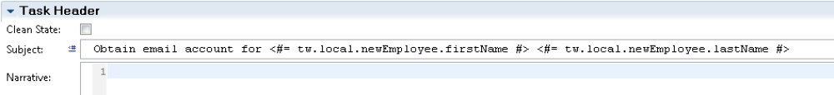

When it is shown in the Process Portal, it could look as follows:
在Process Portal里，它可能显示的内容如下：

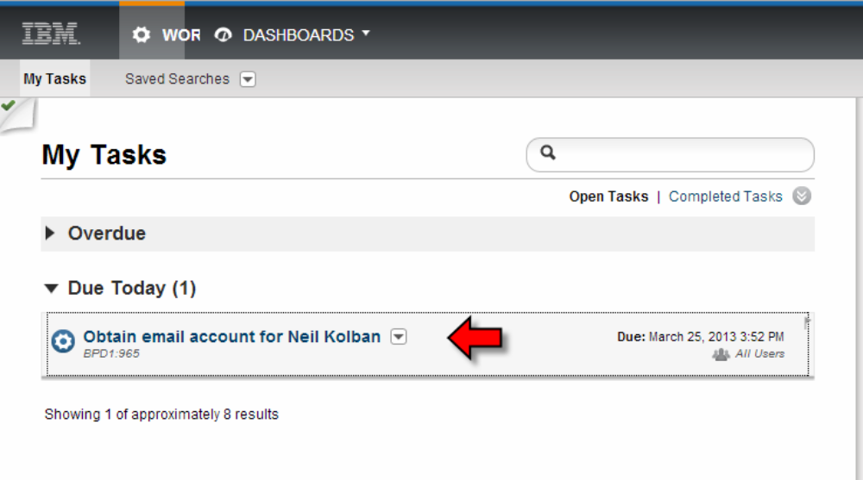

If the Clean Slate check box is selected then at the conclusion of the activity, state data about the activity is discarded.

如果选中了清除状态 的单选框，活动的结论、状态数据都将被丢弃。

Each of the service types has a diagram in which the artifacts which implement that service can be placed and visually wired together. The service editors have a feature within them to "tidy" their appearance by lining up activities to smooth out the sequence connection lines. This option can be found when right-clicking on the diagram canvas with nothing else selected. From the resulting context menu, the Tidy Layout option may be selected.

每一个服务的类型都会绘制一个图表，它实现了服务可以放置并且连接好展现出来。每一个服务编辑器在内部通过连接活动使序列连接线平滑来“梳理” 外观的功能。什么都不选然后右键单击画布可以看到这个选项。在显示出来菜单里，可以选中 “美化布局”选项。

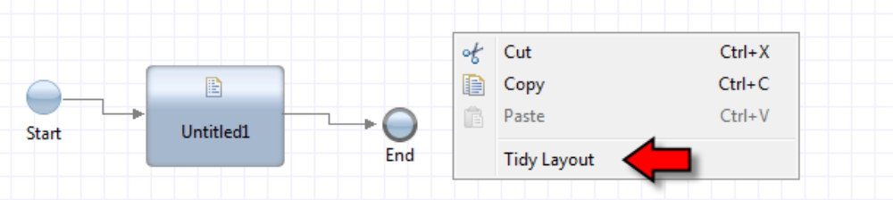

After having selected that entry, the diagram will be reworked to tidy it. An example after a tidy looks as follows:

当选中单击之后，图表将会重新调整，调整后布局如下：

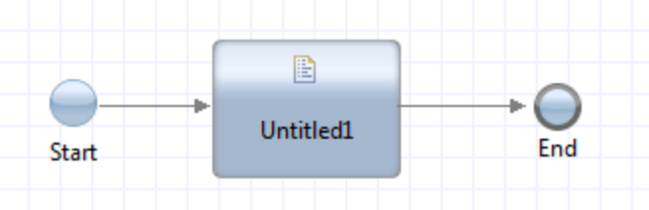

Caching the results of a service
When a service is executed, it is passed in a set of parameters and returns a set of results. If the service is executed over and over again with the same input parameters, it is likely that the result will be the same even though the work of executing the logic of the service will still be performed. As an optimization and as a way to improve performance, we have the ability to flag that a service is eligible to cache its results. This means that for a given service with a given set of inputs, the service will be executed but the results stored. If a subsequent request for the same service with the same set of inputs should arrive, the previously calculated results will be returned without having to execute the logic of the service itself.

服务的缓存结果机制

当服务执行的时候，它会传递一系列参数进去然后返回一系列结果。如果一个服务传递的参数是相同的，那么它就会一遍又一遍的执行，逻辑执行的服务工作一直在运行，其返回的结果是一样的。如果用优化的方式去提高性能，我们可以去标注一个可以保存其结果的服务。这就意味着对于一个输入一系列参数的时候，这个服务会正常执行，并且它的返回结果保存下来了。如果后续的请求通过同样的服务并且传入的参数也是一样的时候，最后返回的将会是之前计算的结果，而不是再把这个服务的逻辑功能执行一遍。

This feature can be turned on or off on a per service basis. In the Overview tab of the service definition, we find an entry called "Service Result Cache":

这个功能我们可以在每一个服务上开启或者关闭。在一个服务的定义预览标签里，我们可以看到一个名叫“服务结果缓存”的选项。

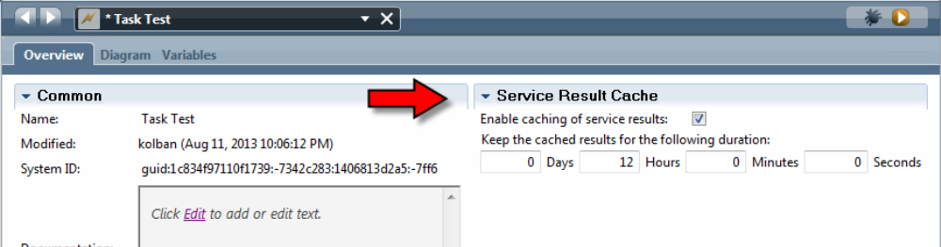

By default, the caching of the service is disabled. If we enable it by clicking on the check box, the results of that service will be cached. We also have the ability to specify how long cached results should be maintained before we consider them "stale". We can supply an interval value after which a previously returned entry will be considered out of date and the real service will again be executed.

在默认情况下， 服务的缓存是关闭状态的。我们只需要轻轻的点击下复选框，缓存模式将会开启。服务的结果将会以缓存的模式保存下来。当然我们也可以自己定义这些缓存的数据需要保留多久。我们可以定义一个时间，这个时间可以表示我们认为的到期时间，当到这个时间的时候，系统就会认为之前缓存的数据已经过期了，然后重新执行服务再把执行的数据放到缓存里。

The implementation of the caching mechanism in IBM BPM has a default cache size of 4096 entries. This can be changed through the <service-result-cache-size> property in the configuration files.

在IBM BPM 里，缓存机制实现容量有一个默认的值，可以存至少4096个实体对象。当然容量也可以通过配置文件里一个叫“服务结果缓存容量”的 属性来调整大小。

Notes:
1. It is not yet known if 4096 is the size of all service cache entries or a single service cache
size
2. It is not yet known what happens when we try and cache more than 4096 entries. Will the
latest entry simply not be cached or will another cache entry be purged?

注意：
- 目前还不知道4096个实体对象是针对所有的服务总共的缓存容量还是针对每一个服务的缓存容量
- 还有一个不知道的地方是当缓存量超过4096之后会发生什么事情，是不把最新的记录保存到缓存里还是把其他的删掉保存新的。

Human Service
人员服务

The Human Service is arguably the most important service type in IBPM. A Human Service is a component that, when executed, creates a task for a human being to work upon. The BPD process is suspended until the conclusion of that task. The Human Service type provides the inclusion of Coach components which are the descriptions of screen data to be presented to users and data to be retrieved from users.

在IBPM 里，人员服务是公认的最重要的一种服务类型。人员服务就是一套组件， 在执行的时候，它会创建一个任务给相应的人员去做。 在BPD里面，当调用的服务执行的时候，BPD会被挂起直到这个任务执行完成。人员服务的类型提供了coach 组件。Coach 就是对于展示用户界面的数据和从用户返回数据的描述。

With the arrival of IBM BPM 8.5.5, the Human Service implementation was massively revamped.
This saw the introduction of a new type of Human Service which IBM calls "Client-Side Human
Services". To maintain backwards compatibility for solutions built prior to 8.5.5, the previous Human Services implementation was left intact and has been renamed to be "Heritage Human Services".

随着IBM BPM 8.5.5 的问世，人员服务进行了大规模修整。一种新的人员服务类型IBM称之为“客户端人员服务“将会呈现在你面前。对于8.5.5，考虑到向下兼容的原则，人员服务除了重新被命名为”旧版人员服务“其实现功能保持完整不变。

A new Human Service is created from the User Interface category.
我们可以通过 用户界面栏里创建一个人员服务。

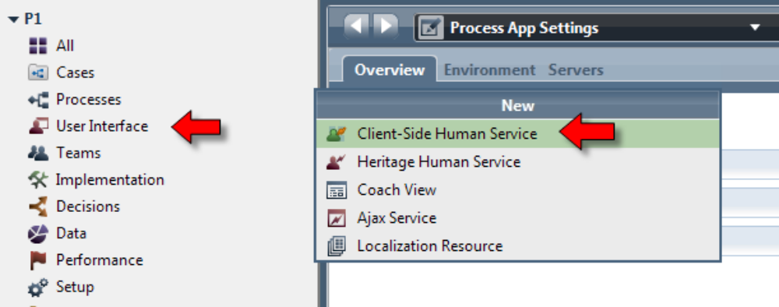

It is extremely common to associate the Human Service definition with a User Task on a BPD.

在BPD 里面最常见的是把一个人员服务的定义和一个用户的任务关联起来。

See also:
• User Task
请参考本书后面关于用户任务的描述
- 用户任务

Exposing the Human Service for starting

公开人员服务启动

In the Overview panel of the Human Service definition, the Exposing section allows us to select how the service should be exposed for starting in a manner other than being explicitly called by a BPD.

在人员服务定义的概述面板上，用户可以选择如何把服务公开。除非这个服务已经明确是被BPD调用，在某种意义上说，这个服务是应该被公开出来。

